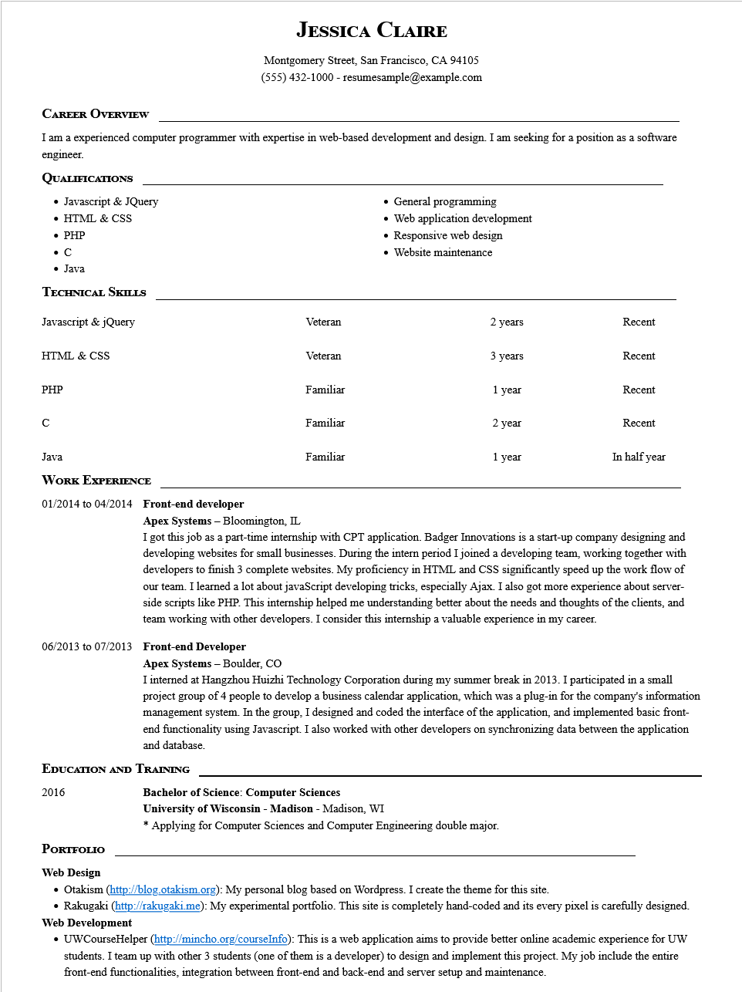
JESSICA CLAIRE
Montgomery Street, San Francisco, CA 94105
(555) 432-1000-resumesample@example.com
CAREER OVERVIEW
I am a experienced computer programmer with expertise in web-based development and design. I am seeking for a position as a software engineer.
QUALIFICATIONS
• Javascript & JQuery
• HTML & CSS
• PHP
• C
• Java
TECHNICAL SKILLS
General programming
• Web application development
• Responsive web design
• Website maintenance
Javascript & jQuery
Veteran
2 years
Recent
HTML & CSS
Veteran
3 years
Recent
Familiar
1 year
Recent
PHP
Familiar
2 year
Recent
с
Familiar
1 year
In half year
Java
WORK EXPERIENCE
01/2014 to 04/2014 Front-end developer
Apex Systems - Bloomington, IL
I got this job as a part-time internship with CPT application. Badger Innovations is a start-up company designing and developing websites for small businesses. During the intern period I joined a developing team, working together with developers to finish 3 complete websites. My proficiency in HTML and CSS significantly speed up the work flow of our team. I learned a lot about javascript developing tricks, especially Ajax. I also got more experience about server- side scripts like PHP. This internship helped me understanding better about the needs and thoughts of the clients, and team working with other developers. I consider this internship a valuable experience in my career.
06/2013 to 07/2013 Front-end Developer
Apex Systems - Boulder, CO
I interned at Hangzhou Huizhi Technology Corporation during my summer break in 2013. I participated in a small project group of 4 people to develop a business calendar application, which was a plug-in for the company's information management system. In the group, I designed and coded the interface of the application, and implemented basic front- end functionality using Javascript. I also worked with other developers on synchronizing data between the application and database.
EDUCATION AND TRAINING
2016
PORTFOLIO
Web Design
Bachelor of Science: Computer Sciences
University of Wisconsin-Madison - Madison, WI
* Applying for Computer Sciences and Computer Engineering double major.
• Otakism (http://blog.otakism.org): My personal blog based on Wordpress. I create the theme for this site.
• Rakugaki (http://rakugaki.me): My experimental portfolio. This site is completely hand-coded and its every pixel is carefully designed. Web Development
• UWCourseHelper (http://mincho.org/courseInfo): This is a web application aims to provide better online academic experience for UW students. I team up with other 3 students (one of them is a developer) to design and implement this project. My job include the entire front-end functionalities, integration between front-end and back-end and server setup and maintenance.

